ExpenseMate (24k-3099 & 24k-3041)
Architectural Style Selection
For ExpenseMate, a Client-Server Architecture operating alongside a Backend N-Layered Architecture is selected.
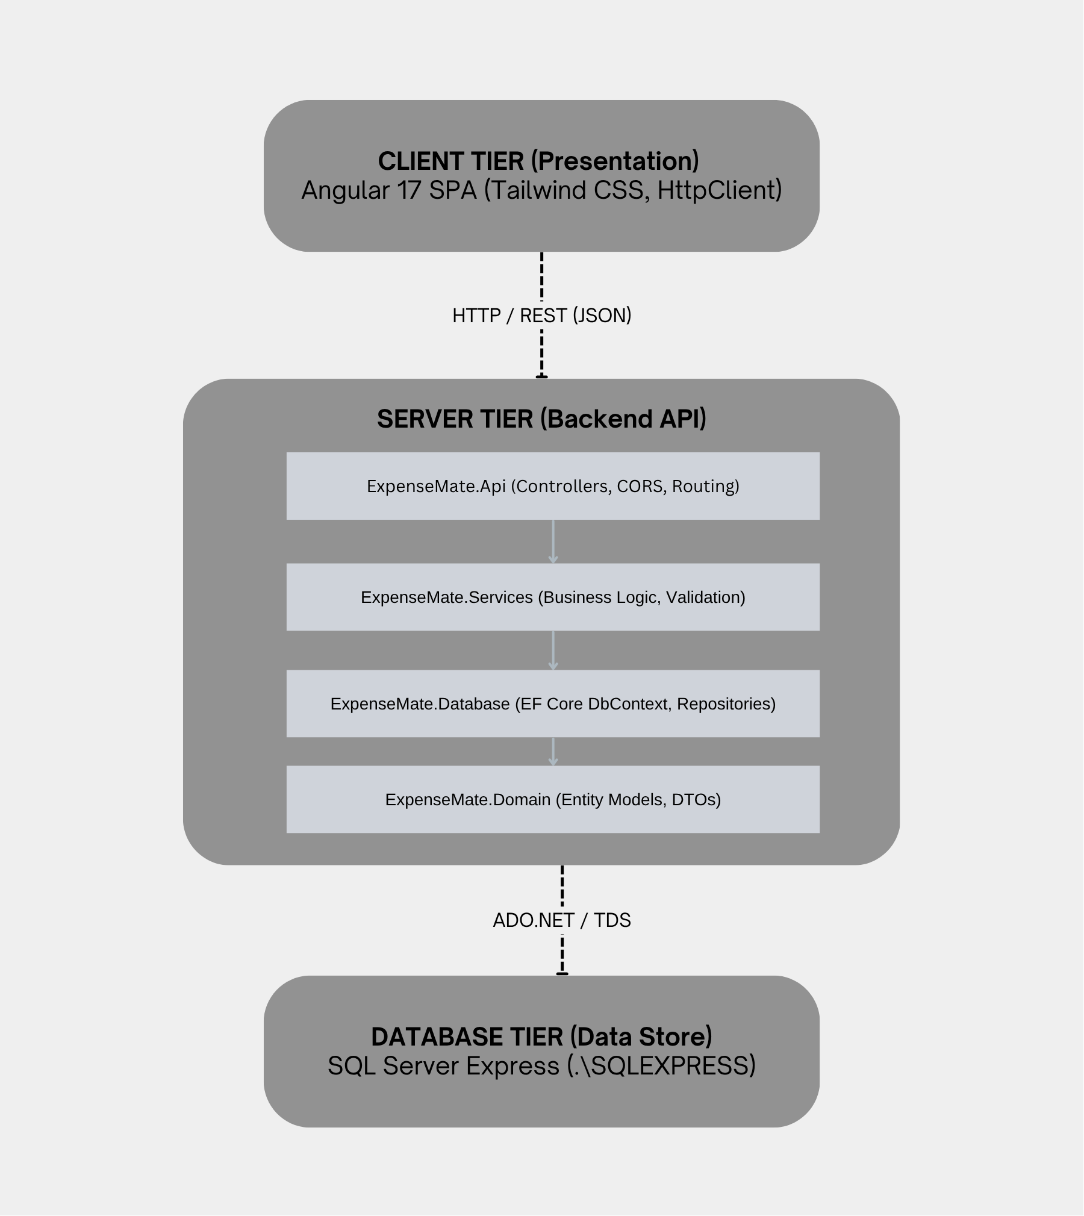
Architectural Views (4+1 View Model)
Logical View
Decomposes the system into functional components and layer responsibilities:
ExpenseMate
├── expense-mate-ui (Presentation Layer)
│ ├── Core (Models, Services, Interceptors)
│ ├── Features (Dashboard, Expense, Income, Budget Components)
│ └── Shared (Navbar, UI Utility Components)
├── ExpenseMate.Api (API Controller Layer)
│ ├── ExpenseController, IncomeController, BudgetController
│ └── Program.cs (CORS Configuration, DI Container)
├── ExpenseMate.Services (Business Logic Layer)
│ └── ExpenseService, IncomeService, BudgetService
├── ExpenseMate.Database (Data Access Layer)
│ ├── ExpenseMateDbContext, Repositories
│ └── Migrations (EF Core Schema Versions)
└── ExpenseMate.Domain (Core Entity Layer)
└── Expense, Income, Budget Domain Models & DTOs

Process View
Traces runtime execution and data flow across tiers during a user action:
[User] -> (Submit Expense Form)
│
▼
[ExpenseComponent] calls ExpenseService.addExpense(expense)
│
▼
[HttpClient] sends POST https://localhost:7123/api/Expense (JSON)
│
▼
[ExpenseController] receives HTTP request -> routes to ExpenseService
│
▼
[ExpenseService] validates business rules -> invokes ExpenseRepository
│
▼
[ExpenseMateDbContext] generates SQL -> executes INSERT INTO dbo.Expense
│
▼
[SQL Server Express] persists record -> returns generated ExpenseId
│
▼
[ExpenseController] returns HTTP 201 Created -> Angular updates UI state

Physical View
Maps soft architectural elements to hardware nodes and execution runtimes:

Node | Operating Runtime | Host / Port | Responsibilities
Client Workstation | Web Browser (Chrome/Edge) | http://localhost:4200 | Renders Angular SPA, executes client-side logic
Application Web Server | .NET 8 Kestrel Web Server | https://localhost:7123 | Host Web API, execute middleware & EF Core
Database Server | SQL Server Express Engine | .\SQLEXPRESS (Port 1433) | Physical storage, indexing, and transactional integrity

Deployment View
Defines how source code artifacts compile and deploy onto host nodes:
+------------------------------------------------------------------------+
| Client Machine / Node Runtime |
| └── /expense-mate-ui/dist/ (Static HTML/JS/CSS bundles) |
+------------------------------------------------------------------------+
│ (REST API calls)
▼
+------------------------------------------------------------------------+
| Host Server / .NET Runtime |
| ├── ExpenseMate.Api.dll |
| ├── ExpenseMate.Services.dll |
| ├── ExpenseMate.Database.dll |
| └── ExpenseMate.Domain.dll |
+------------------------------------------------------------------------+
│ (TDS Protocol / Connection String)
▼
+------------------------------------------------------------------------+
| Database Host / SQL Server Engine |
| └── ExpenseMate.mdf (Database File) |
+------------------------------------------------------------------------+

Coding Standards & Tools

Technology Stack & Tooling
- IDE / Editors: Visual Studio Code, SQL Server Management Studio (SSMS)
- Frameworks: .NET 8 Web API, Angular 17+ (Standalone Components)
- ORM & Database: EF Core 8 (Code-First), SQL Server Express
- Styling & UI: Tailwind CSS v3
- Package Managers: NuGet (.NET), npm (Node.js)
Coding Conventions
C# / .NET Standards
- Naming:
  - PascalCase for class names, interfaces (IExpenseService), public properties, and methods.
  - camelCase for private fields (_context) and method parameters.
- Asynchronous Programming: Use async/await pattern across all database and network interactions (ToListAsync(), SaveChangesAsync()).
- Dependency Injection: Register all repositories and services using explicit lifecycles (AddScoped) in Program.cs.
TypeScript / Angular Standards
- Naming:
  - camelCase for variables, properties, and functions.
  - PascalCase for interfaces (Expense) and component classes (ExpenseComponent).
- Architecture: Enforce Standalone Components (standalone: true); separate API communication into dedicated service files inside core/services/.

Construction Timeline & Gantt Chart

Work Breakdown Structure (WBS)
- Phase 1: Backend Development
  - 1.1 Database schema definition & EF Core migrations
  - 1.2 Repositories & Business Service logic implementation
  - 1.3 Web API Controllers & CORS configuration
- Phase 2: Frontend Development
  - 2.1 Angular project initialization & Tailwind CSS integration
  - 2.2 Core models, services (HttpClient), and navigation layout
  - 2.3 Feature views (Expenses, Income, Budget components)
- Phase 3: Integration & Testing
  - 3.1 End-to-end API integration & CORS testing
  - 3.2 UI styling refinement & validation checks

Task Name | Week 1 | Week 2 | Week 3 | Week 4
1.1 Schema & Migrations
1.2 Repositories & Services
1.3 API Controllers & CORS
2.1 Angular Setup & Tailwind
2.2 Models & Services
2.3 Feature Components
3.1 E2E Integration Testing
3.2 UI Polishing & Final Review

